SIMATS ENGINEERING
(SAVEETHA SCHOOL OF ENGINEERING)
Department of Computer Science and Engineering

CO1 ASSESSMENT TOOL 2
AGILE SPRINT PLANNING
& USER STORY WORKSHOP
Project: Digital Document Management System

Assessment Details | Information
Course Code | CSA10 / CSA1004
Course Title | Software Engineering
Course Outcome | CO1 – Apply advanced methodologies and agile project management techniques to manage software projects effectively
Student Name | K. Chandana
Registration Number | 192525363
Assessment Weightage | 20%
Total Marks | 25
Sprint Duration | 1 week (proposed)

Declaration / Code of Conduct
I, K. Chandana (Reg. No. 192525363), declare that this document has been prepared for the CO1 Assessment Tool 2 – Agile Sprint Planning & User Story Workshop. I understand the importance of academic integrity and will ensure that any actual implementation evidence submitted with this report represents work completed and verified by me.
Student Signature: __k. Chandana_ Date: ________________

Abstract
The Digital Document Management System (DDMS) is a proposed secure platform that helps an organization upload, categorize, search, share, version, and manage access to important digital documents. This report applies Agile sprint planning practices to the project. It defines the project vision and stakeholders, organizes requirements into epics and user stories, provides measurable acceptance criteria, prioritizes the product backlog, estimates effort using Fibonacci story points, and plans a realistic one-week sprint. Illustrative workflow and interface mockups are included to explain the expected system behavior. They are design illustrations, not screenshots from a deployed application.

Contents
- 1. Project Overview and Vision
- 2. Stakeholder Identification
- 3. System Scope and Requirements
- 4. Epics and User Stories
- 5. Acceptance Criteria
- 6. Prioritized Product Backlog
- 7. Sprint Backlog and Task Breakdown
- 8. Story Point Estimation
- 9. Sprint Goal and Deliverables
- 10. Design and Implementation Plan
- 11. Testing and Definition of Done
- 12. Risks, Mitigation and Future Enhancements
- 13. Conclusion
- Appendix A – Sprint Review Checklist
- References

1. Project Overview and Vision

1.1 Problem Statement
Organizations handle many digital files such as reports, forms, project documents, invoices, and policies. When files are stored in unrelated folders or shared through informal channels, users may struggle to find the latest version, identify the correct document, control access, and track changes. The proposed DDMS provides a centralized and organized way to manage these documents.

1.2 Project Vision
To provide a simple, secure, and reliable digital workspace where authorized users can store, find, share, and maintain the correct version of organizational documents.

1.3 Objectives
- Provide secure user sign-in and role-based access to document functions.
- Allow authorized users to upload documents with a title, category, and description.
- Make documents easier to locate through keyword search and category filters.
- Maintain version history so users can identify the latest revision.
- Support controlled sharing and prevent unauthorized access.
- Provide a clear interface and a testable, incremental delivery plan.

1.4 Scope
In Scope for the proposed system | Outside the first sprint / future scope
Login screen and basic role model | Enterprise single sign-on integration
Document upload and metadata | Large-scale cloud migration
Search and category filtering | AI-based document summarization
Basic sharing permissions | Advanced digital signatures
Version history concept | Mobile application and multilingual support

2. Stakeholder Identification
Stakeholder | Role / Need | Involvement
Document Owner / Employee | Uploads and updates files; needs quick search and reliable storage. | Provides requirements; validates upload and search flows.
Team Member / Reader | Views documents shared with them. | Checks viewing and permission behavior.
Administrator | Manages users, roles, and access policies. | Defines roles and reviews access controls.
Project Guide / Product Owner | Clarifies requirements and decides priority. | Approves backlog priorities and sprint goal.
Development Team | Designs, implements, and tests the features. | Estimates tasks and delivers the increment.
Tester / Reviewer | Checks acceptance criteria and defects. | Executes test cases and reports issues.

3. System Scope and Requirements

3.1 Functional Requirements
- FR-01: The system shall allow a registered user to sign in using valid credentials.
- FR-02: The system shall allow an authorized user to upload a supported document.
- FR-03: The system shall store title, category, owner, upload date, and version metadata.
- FR-04: The system shall display a list of documents available to the signed-in user.
- FR-05: The system shall search documents by title or keyword.
- FR-06: The system shall restrict document access according to permissions.
- FR-07: The system shall record a new version when an existing document is updated.
- FR-08: The system shall allow a user to sign out securely.

6.1 Definition of Ready
- The story has a clear user and business benefit.
- Acceptance criteria are written and testable.
- Dependencies and permission requirements are identified.
- The team can estimate the work and understands the expected outcome

7.2 Daily Plan
Day | Planned focus | Expected evidence
Day 1 | Confirm stories, acceptance criteria, and basic interface. | Approved sprint backlog and screen sketch.
Day 2 | Complete login flow and start upload form. | Login flow tested; upload form visible.
Day 3 | Implement upload validation and document metadata. | Valid and invalid upload scenarios checked.
Day 4 | Connect repository listing to uploaded document records. | Uploaded document appears in the list.
Day 5 | Integrate, test, fix, review, and demonstrate. | Test results, demo, and retrospective notes.

8. Story Point Estimation
Planning Poker with the Fibonacci sequence (1, 2, 3, 5, 8, 13) is proposed. The team compares relative complexity, uncertainty, and effort. A 5-point story is expected to be more complex than a 3-point story; points are not direct hours.

Story | Points | Justification
US-01 Sign in | 5 | Form validation, authentication outcome, error handling, and protected-route checks.
US-02 Upload | 5 | File selection, metadata validation, storage record, and success/failure handling.
US-03 Repository | 3 | Basic list view and display of stored metadata; depends on document records.
US-04 Search | 5 | Keyword matching, result display, no-results state, and access filtering.
US-06 Sharing | 8 | Recipient selection, permission enforcement, and negative authorization tests.
US-07 Version history | 5 | Version metadata, ordering, and display logic.

9. Sprint Goal and Expected Deliverables
Sprint Goal: Deliver a basic secure document workflow in which an authorized user can sign in, upload a document with required metadata, view it in the repository, and sign out.

9.1 Expected Deliverables
- Login and sign-out interface with basic validation.
- Document upload form with title, category, and file selection.
- Repository page that displays uploaded document metadata.
- Acceptance test checklist and recorded pass/fail outcomes.
- Demonstration of the complete workflow using sample documents.
- Known-issues list and prioritized items for the next sprint.

9.2 Sprint Board Example
To Do | In Progress | Done (after verification)
Search and filter | Upload validation | Login form (when tested)
Sharing permissions | Repository list | Sign-out flow (when tested)
Version history | Integration testing | —

10. Design and Implementation Plan
The following screens are illustrative interface mockups prepared to communicate the proposed design. They are not captured from a running application. If the assessment requires proof of actual implementation, replace or supplement them with screenshots from the application you run.

10.4 Implementation Sequence
- Create the project structure and database entities for users, documents, and document versions.
- Build and test the login and sign-out flow.
- Build the upload form and validate required metadata and permitted file types.
- Save document metadata and file content using a consistent identifier.
- Display accessible documents in the repository.
- Add search, sharing permissions, and version history in later increments.
- Run test cases and capture genuine screenshots of successful and failed scenarios.

IMPLEMENTATION AND RESULTS
The Digital Document Management System prototype was executed locally using Python and Flask. The following figures are genuine screenshots captured from the running application during the implementation test.
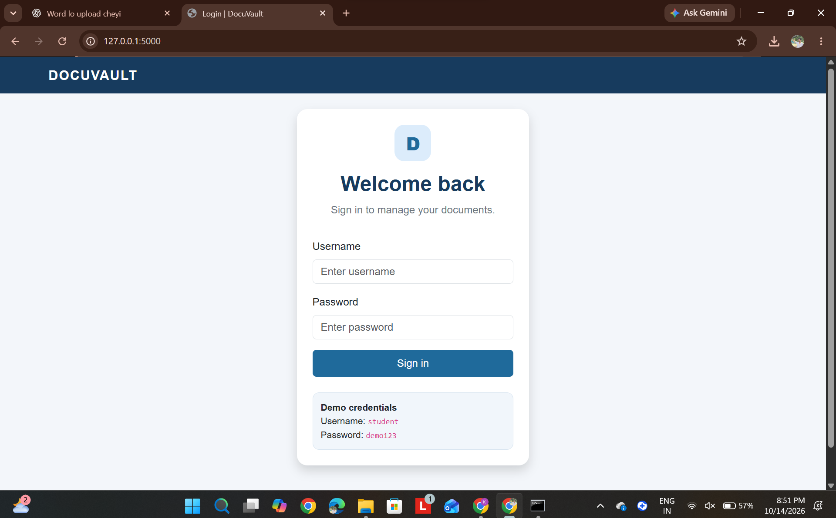
Figure 1. Login page of the running DocuVault application. The demo login form is displayed in the browser.

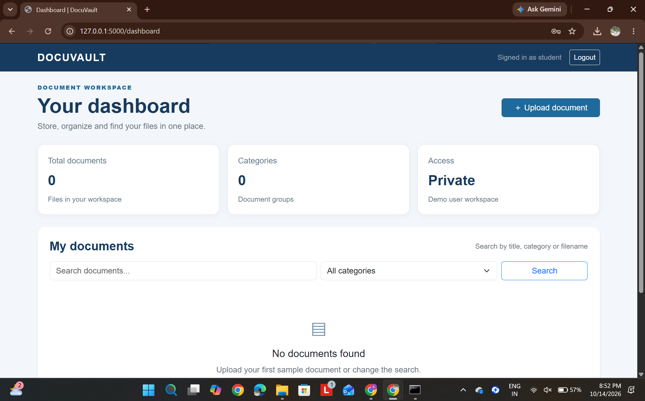
Figure 2. Dashboard after successful login. The dashboard displays document totals, category count, search, and upload controls.

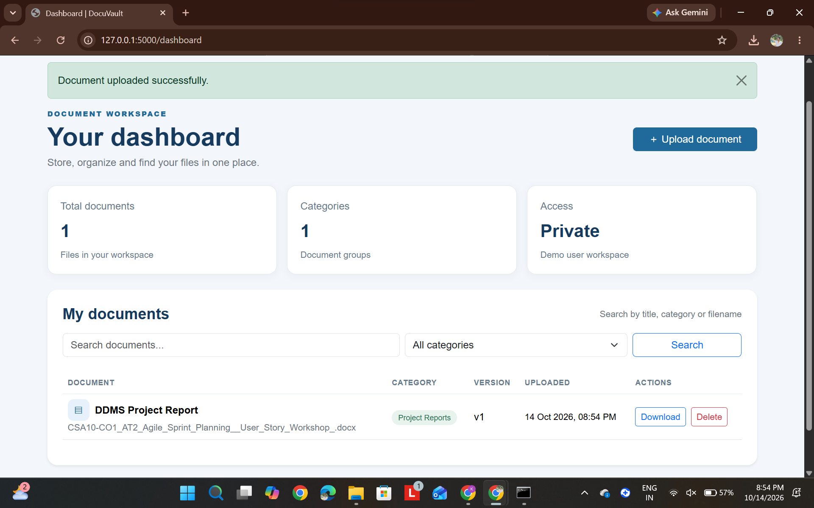
Figure 3. Successful document upload. The dashboard confirms the upload and lists the sample document with its category, version, upload time, and actions.

